Q1 Single File Programming Question
IDENTIFY CLIENTS WITH THE HIGHEST API USAGE
The billing analytics team at FormNest, a subscription-based API service provider, wants to recognize the clients who use the service most intensively. Specifically, they want to identify the client (or clients) who have made the highest number of API calls across the entire platform, so these power users can be offered priority onboarding to a new enterprise support tier.
Task: Write a query that uses a subquery with MAX to determine the highest api_calls value in the client_usage table, and then returns every client whose api_calls equals that maximum value. If more than one client shares the highest api_calls value, all such clients must appear in the result.

The output must contain the following columns:
- client_id — Unique identifier of the client
- plan_name — The client's current subscription plan
Order the final output by client_id in ascending order.
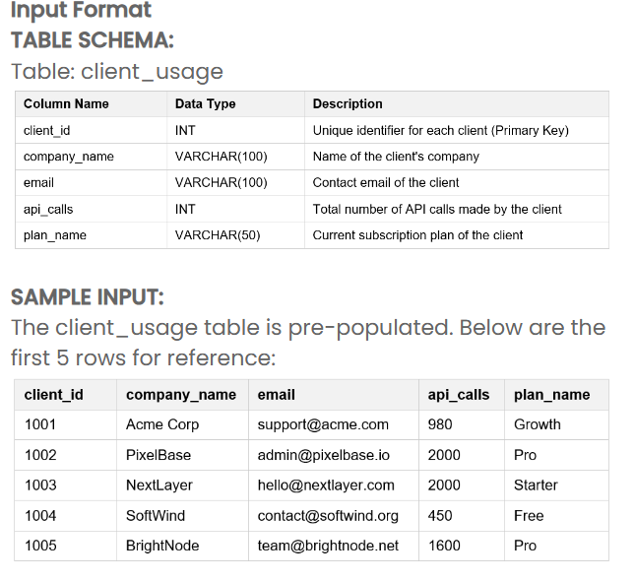
Table: client_usage

Output Format
Return the following columns, in this exact order:
client_id | plan_name
SAMPLE OUTPUT:
Based on the 5 sample input rows above, the expected output would be:
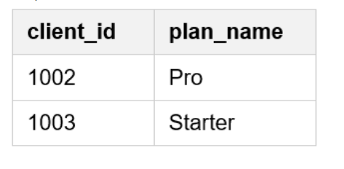
EXPLANATION:
Among the 5 sample rows, the highest api_calls value is 2000, made by clients 1002 (PixelBase) and 1003 (NextLayer). The subquery SELECT MAX(api_calls) FROM client_usage returns 2000, and the outer query returns every client whose api_calls equals 2000. Within the sample window, clients 1002 and 1003 both reach that value, so both appear. The full dataset contains a third client (1006) who also made 2000 API calls, and the complete expected output — ordered by client_id ascending — is shown below.
Constraints
- Keywords, table names, column names, and record values are case-sensitive.
- All records are pre-populated. No console input is required.
- Use the exact output column names: client_id and plan_name.
- You must use a subquery with MAX to determine the highest api_calls value.
- If multiple clients share the highest api_calls value, return all of them.
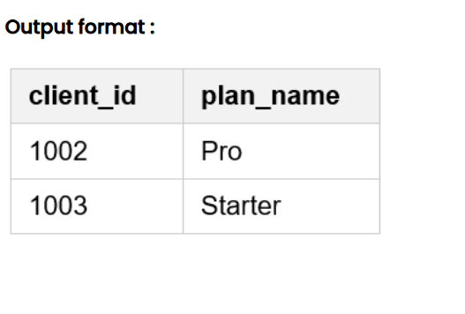
Output format :
Note :
The program will be evaluated only after the “Submit Code” is clicked.
Extra spaces and new line characters in the program output will result in the failure of the test case.
SELECT client_id,
plan_name
FROM client_usage
WHERE api_calls = (
SELECT MAX(api_calls)
FROM client_usage
)
ORDER BY client_id;

Q2 Single File Programming Question
PACKAGE DELIVERY HUB - HIGH-VOLUME DELIVERY ZONES
The operations team at a national courier company wants to analyze delivery load across the different zones it serves. Every individual shipment is captured in the delivery log with its zone and package weight. To plan staffing and logistics, the team wants to focus only on the high-volume zones — those handling a meaningful amount of shipped weight — and rank them by the total weight handled.

Task: Produce a summary report, grouped by delivery zone, that shows for each zone the total number of deliveries and the total package weight (in kilograms) shipped to that zone. Include only zones whose total shipped weight is at least 25 kilograms. Order the final output by total_weight in descending order, so the zones handling the heaviest loads appear at the top.

The output must contain the following columns, in this exact order:
- delivery_zone — The delivery zone name
- total_deliveries — Total number of deliveries made to that zone
- total_weight — Total package weight (in kilograms) shipped to that zone

Input Format
TABLE SCHEMA:
Table: deliveries
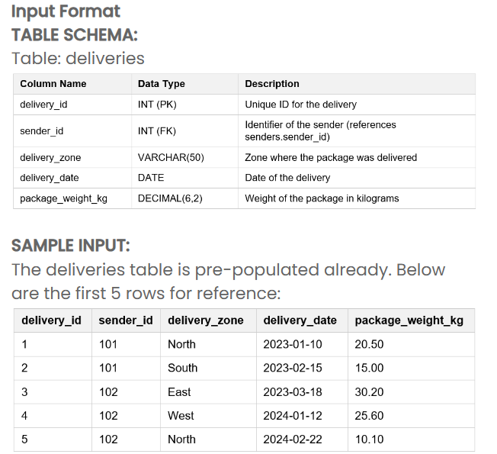
OUTPUT FORMAT:
Return the following column names, in this exact order:
delivery_zone | total_deliveries | total_weight
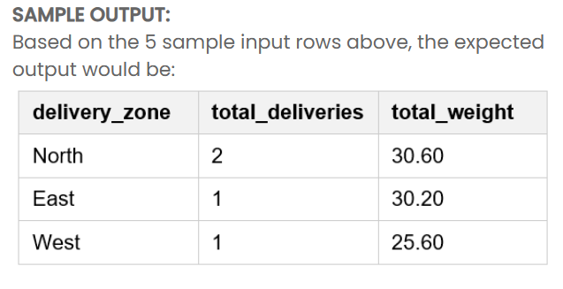

SAMPLE OUTPUT:
Based on the 5 sample input rows above, the expected output would be:

EXPLANATION:
From the 5 sample rows there are four zones. North has 2 deliveries (20.50 + 10.10 = 30.60 kg), East has 1 delivery (30.20 kg), West has 1 delivery (25.60 kg), and South has 1 delivery (15.00 kg). The HAVING clause keeps only zones whose total weight is at least 25 kg, so South (15.00 kg) is excluded. The remaining zones are ordered by total_weight in descending order: North (30.60), then East (30.20), then West (25.60). The full dataset contains additional rows and one more zone, and the complete expected output is shown below.
Constraints
- Keywords, table names, column names, and record values are case-sensitive.
- All records are pre-populated. No console input is required.
- Use the exact output column names: delivery_zone, total_deliveries, and total_weight.
- Group the results by delivery_zone only (single column GROUP BY).
- Include only zones whose total weight is at least 25 kg, using a HAVING clause.
- Order the output by total_weight in descending order only (single column ORDER BY).
Output format :
Note :
The program will be evaluated only after the “Submit Code” is clicked.
Extra spaces and new line characters in the program output will result in the failure of the test case.
SELECT
delivery_zone,
COUNT(*) AS total_deliveries,
SUM(package_weight_kg) AS total_weight
FROM deliveries
GROUP BY delivery_zone
HAVING SUM(package_weight_kg) >= 25
ORDER BY total_weight DESC;

